Station 3 and 4  Describe the 3 properties of population? ___________________________________________________________________________________________________________________________________  Using those 3 properties  Compare any 2 populations.  Compare/Contrast Density Dependent to Density Independent & give an example |  |  | Name_____________________  Block____________  Company Name  Street Address  City, ST ZIP Code |  | Population Test  Stations Rotation  Station #  What is the diagram above called?  _______________________________  What information is provided from this diagram__________________________  F.A.T. Answer How do the two countries populations compare?  ____________________________________________________________________________________________________________________

Station #6: List and describe the 4 stages of Demographic Transition  - _________________________________________________________________________________  - _________________________________________________________________________________  - _________________________________________________________________________________  - _________________________________________________________________________________  Label the graph accordingly  _________ __________ ________ __________  Label the following types of dispersion  ________ _________ _________  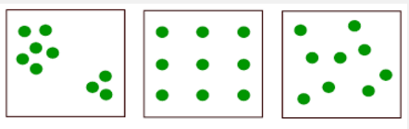 | Station #5 Website  View the following Video: Identify the 5 types of interactions that can occur between living things:  - Commensalism__________________________________________________________  - Mutualism______________________________________________________________  - Parasitism______________________________________________________________  - Predation_______________________________________________________________  - Competition  Between Species:  ______________________________________________________________________________  Within Species:  ______________________________________________________________________________ |  | Station #2 Spider Diagram  Read the article on populations, fill in the spider diagram with key points and ideas from the reading. National Geographic Article  Unit 2  migration

